- Convert Selenium Java code to Playwright code in Chatgpt:
Selenium:
package week2.day1;

import org.openqa.selenium.By;
import org.openqa.selenium.WebElement;
import org.openqa.selenium.chrome.ChromeDriver;
import org.openqa.selenium.support.ui.Select;

import io.github.bonigarcia.wdm.WebDriverManager;

public class CreateLead {

public static void main(String[] args) {

// Step 0) Setup the chromedriver using webdrivermanager software
WebDriverManager.chromedriver().setup();

// Step 1) Launch the chrome browser (Class Name -> ChromeDriver)
ChromeDriver driver = new ChromeDriver();

// Step 2) Load the URL (http://leaftaps.com/opentaps/control/main) -> get
driver.get("http://leaftaps.com/opentaps");

// Step 3) Maximize the chrome browser
driver.manage().window().maximize();

// Step 4) Find the username and type the value (DemoSalesManager)
driver.findElement(By.id("username")).sendKeys("DemoSalesManager");

// Step 5) Find the password and type the value (crmsfa)
driver.findElement(By.id("password")).sendKeys("crmsfa");

// Step 6) Find the login button and click
driver.findElement(By.className("decorativeSubmit")).click();

// Step 7) Verify the title
String title = driver.getTitle();
System.out.println(title);

// Step 8) Click CRM/SFA link
driver.findElement(By.linkText("CRM/SFA")).click();

// Step 9) Click Create Lead Link
driver.findElement(By.linkText("Create Lead")).click();

// Step 10) Find the company name and type the company name
driver.findElement(By.id("createLeadForm_companyName")).sendKeys("TestLeaf");

// Step 11) Find the first name and type your name
driver.findElement(By.id("createLeadForm_firstName")).sendKeys("Babu");

// Step 12) Find the last name and type your name
driver.findElement(By.id("createLeadForm_lastName")).sendKeys("Manickam");

// Step 12 b) Select the Source dropdown with one of the visible text
WebElement source = driver.findElement(By.id("createLeadForm_dataSourceId"));
Select dd1 = new Select(source);
dd1.selectByVisibleText("Employee");

// Step 12 c) Select the marketing campaign with one of the value
WebElement marketing = driver.findElement(By.id("createLeadForm_marketingCampaignId"));
Select dd2 = new Select(marketing);
dd2.selectByValue("9001");

// Step 13) Click Create Lead Button
driver.findElement(By.name("submitButton")).click();

// Step 14) Print the new title
title = driver.getTitle();
System.out.println(title);

}

}

Prompt :
Context:
You are an AI assistant to convert selenium java code to Playwright code using typescript

Given the following Selenium Java code:

package week2.day1;

import org.openqa.selenium.By;
import org.openqa.selenium.WebElement;
import org.openqa.selenium.chrome.ChromeDriver;
import org.openqa.selenium.support.ui.Select;

import io.github.bonigarcia.wdm.WebDriverManager;

public class CreateLead {

public static void main(String[] args) {

// Step 0) Setup the chromedriver using webdrivermanager software
WebDriverManager.chromedriver().setup();

// Step 1) Launch the chrome browser (Class Name -> ChromeDriver)
ChromeDriver driver = new ChromeDriver();

// Step 2) Load the URL (http://leaftaps.com/opentaps/control/main) -> get
driver.get("http://leaftaps.com/opentaps");

// Step 3) Maximize the chrome browser
driver.manage().window().maximize();

// Step 4) Find the username and type the value (DemoSalesManager)
driver.findElement(By.id("username")).sendKeys("DemoSalesManager");

// Step 5) Find the password and type the value (crmsfa)
driver.findElement(By.id("password")).sendKeys("crmsfa");

// Step 6) Find the login button and click
driver.findElement(By.className("decorativeSubmit")).click();

// Step 7) Verify the title
String title = driver.getTitle();
System.out.println(title);

// Step 8) Click CRM/SFA link
driver.findElement(By.linkText("CRM/SFA")).click();

// Step 9) Click Create Lead Link
driver.findElement(By.linkText("Create Lead")).click();

// Step 10) Find the company name and type the company name
driver.findElement(By.id("createLeadForm_companyName")).sendKeys("TestLeaf");

// Step 11) Find the first name and type your name
driver.findElement(By.id("createLeadForm_firstName")).sendKeys("Babu");

// Step 12) Find the last name and type your name
driver.findElement(By.id("createLeadForm_lastName")).sendKeys("Manickam");

// Step 12 b) Select the Source dropdown with one of the visible text
WebElement source = driver.findElement(By.id("createLeadForm_dataSourceId"));
Select dd1 = new Select(source);
dd1.selectByVisibleText("Employee");

// Step 12 c) Select the marketing campaign with one of the value
WebElement marketing = driver.findElement(By.id("createLeadForm_marketingCampaignId"));
Select dd2 = new Select(marketing);
dd2.selectByValue("9001");

// Step 13) Click Create Lead Button
driver.findElement(By.name("submitButton")).click();

// Step 14) Print the new title
title = driver.getTitle();
System.out.println(title);

}

}

Instructions:
Implementation guidelines:
- Use Latest playwright version
- Import required classes and libraries
- Add Typescript code for methods & class
- [MANDATORY] Every method should have proper comments above method signature
- Do not send any explanation or additional text
- [CRITICAL] add proper timeouts statments if required
- [CRITICAL] Execution should be in headless mode

Prompt Response :

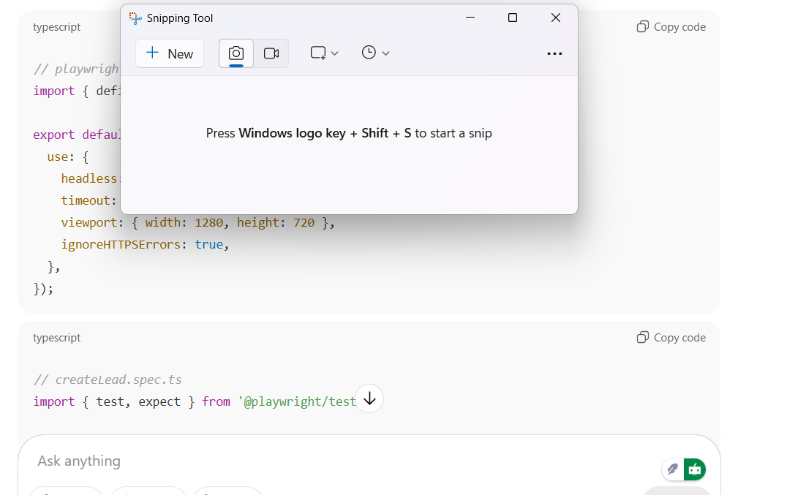

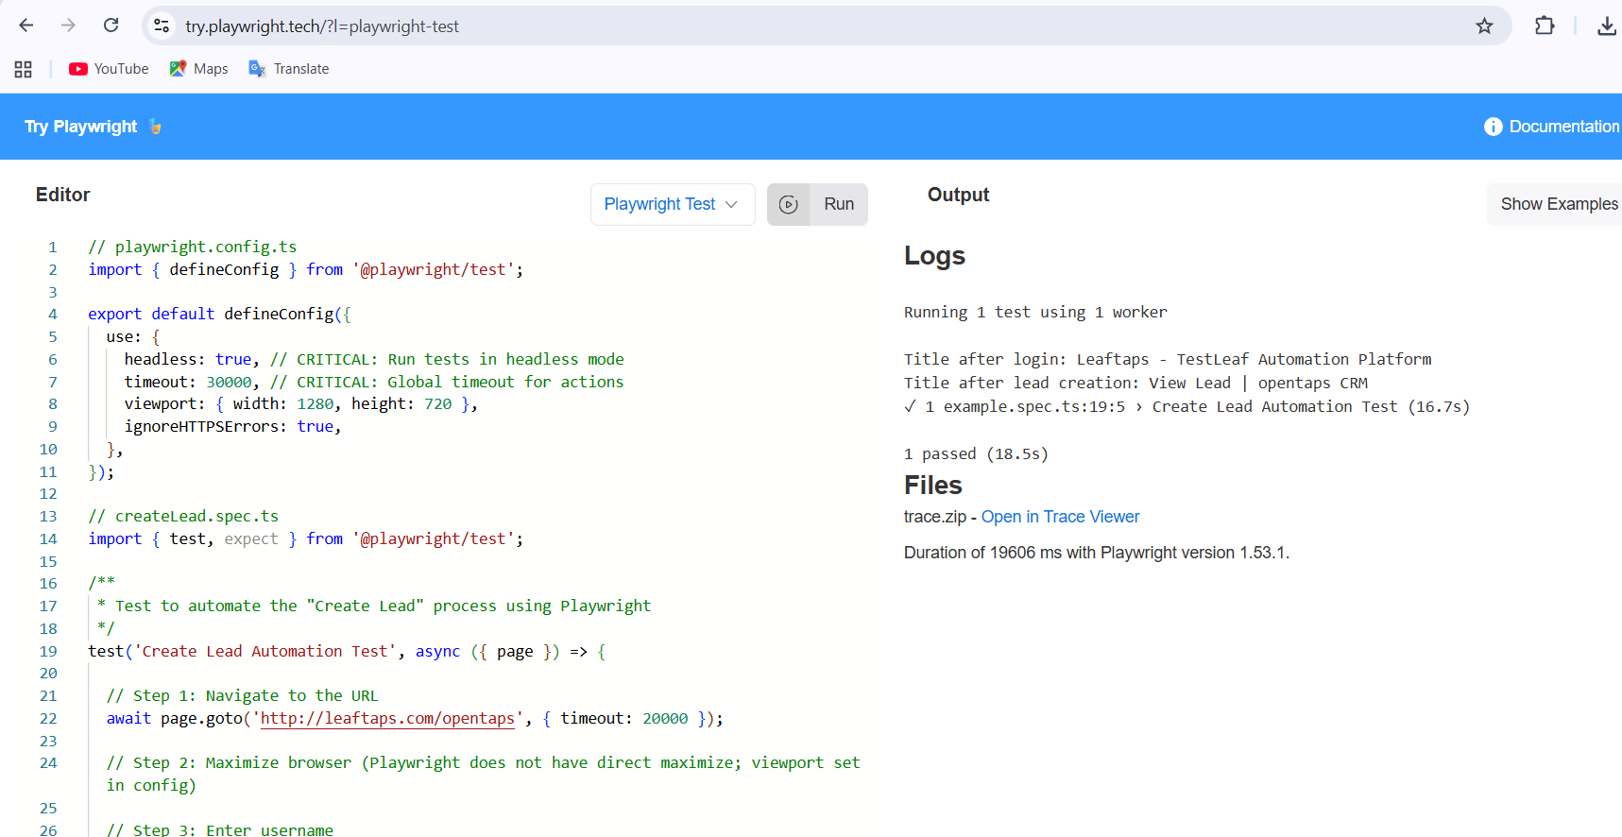

// playwright.config.ts
import { defineConfig } from '@playwright/test';

export default defineConfig({
use: {
headless: true, // CRITICAL: Run tests in headless mode
timeout: 30000, // CRITICAL: Global timeout for actions
viewport: { width: 1280, height: 720 },
ignoreHTTPSErrors: true,
},
});

// createLead.spec.ts
import { test, expect } from '@playwright/test';

/**
* Test to automate the "Create Lead" process using Playwright
*/
test('Create Lead Automation Test', async ({ page }) => {

// Step 1: Navigate to the URL
await page.goto('http://leaftaps.com/opentaps', { timeout: 20000 });

// Step 2: Maximize browser (Playwright does not have direct maximize; viewport set in config)

// Step 3: Enter username
await page.fill('#username', 'DemoSalesManager');

// Step 4: Enter password
await page.fill('#password', 'crmsfa');

// Step 5: Click login button
await page.click('.decorativeSubmit');

// Step 6: Verify title after login
await page.waitForLoadState('domcontentloaded');
console.log('Title after login:', await page.title());

// Step 7: Click CRM/SFA link
await page.click('text=CRM/SFA', { timeout: 5000 });

// Step 8: Click Create Lead link
await page.click('text=Create Lead', { timeout: 5000 });

// Step 9: Enter company name
await page.fill('#createLeadForm_companyName', 'TestLeaf');

// Step 10: Enter first name
await page.fill('#createLeadForm_firstName', 'Babu');

// Step 11: Enter last name
await page.fill('#createLeadForm_lastName', 'Manickam');

// Step 12: Select Source dropdown by visible text
await page.selectOption('#createLeadForm_dataSourceId', { label: 'Employee' });

// Step 13: Select Marketing Campaign dropdown by value
await page.selectOption('#createLeadForm_marketingCampaignId', { value: '9001' });

// Step 14: Click Create Lead button
await page.click('input[name="submitButton"]');

// Step 15: Print the new title
await page.waitForLoadState('domcontentloaded');
console.log('Title after lead creation:', await page.title());
});

Logs
Running 1 test using 1 worker
Title after login: Leaftaps - TestLeaf Automation Platform
Title after lead creation: View Lead | opentaps CRM
✓ 1 example.spec.ts:19:5 › Create Lead Automation Test (16.7s)
1 passed (18.5s)
Files
trace.zip - Open in Trace Viewer
Duration of 19606 ms with Playwright version 1.53.1.

- . Convert Selenium Java code to Playwright code in postman:
Postman request :
{
"messages": [
{
"role": "system",
"content": "You are an AI assistant to convert selenium java code to Playwright code using typescript and Do not send any explanation or additional text"
},
{
"role": "user",
"content": "Convert selenium java code to Playwright code using typescript for Given the Selenium Java code:\n\n\"\"\"\npackage week2.day1;\n\nimport org.openqa.selenium.By;\nimport org.openqa.selenium.WebElement;\nimport org.openqa.selenium.chrome.ChromeDriver;\nimport org.openqa.selenium.support.ui.Select;\n\nimport io.github.bonigarcia.wdm.WebDriverManager;\n\npublic class CreateLead {\n\n public static void main(String[] args) {\n\n // Step 0) Setup the chromedriver using webdrivermanager software\n WebDriverManager.chromedriver().setup();\n\n // Step 1) Launch the chrome browser (Class Name -> ChromeDriver)\n ChromeDriver driver = new ChromeDriver();\n\n // Step 2) Load the URL (http://leaftaps.com/opentaps/control/main) -> get\n driver.get(\"http://leaftaps.com/opentaps\");\n\n // Step 3) Maximize the chrome browser\n driver.manage().window().maximize();\n\n // Step 4) Find the username and type the value (DemoSalesManager)\n driver.findElement(By.id(\"username\")).sendKeys(\"DemoSalesManager\");\n\n // Step 5) Find the password and type the value (crmsfa)\n driver.findElement(By.id(\"password\")).sendKeys(\"crmsfa\");\n\n // Step 6) Find the login button and click\n driver.findElement(By.className(\"decorativeSubmit\")).click();\n\n // Step 7) Verify the title \n String title = driver.getTitle();\n System.out.println(title);\n\n // Step 8) Click CRM/SFA link\n driver.findElement(By.linkText(\"CRM/SFA\")).click();\n\n // Step 9) Click Create Lead Link\n driver.findElement(By.linkText(\"Create Lead\")).click();\n\n // Step 10) Find the company name and type the company name\n driver.findElement(By.id(\"createLeadForm_companyName\")).sendKeys(\"TestLeaf\");\n\n // Step 11) Find the first name and type your name\n driver.findElement(By.id(\"createLeadForm_firstName\")).sendKeys(\"Babu\");\n\n // Step 12) Find the last name and type your name\n driver.findElement(By.id(\"createLeadForm_lastName\")).sendKeys(\"Manickam\");\n\n // Step 12 b) Select the Source dropdown with one of the visible text\n WebElement source = driver.findElement(By.id(\"createLeadForm_dataSourceId\"));\n Select dd1 = new Select(source);\n dd1.selectByVisibleText(\"Employee\");\n\n // Step 12 c) Select the marketing campaign with one of the value\n WebElement marketing = driver.findElement(By.id(\"createLeadForm_marketingCampaignId\"));\n Select dd2 = new Select(marketing);\n dd2.selectByValue(\"9001\");\n\n // Step 13) Click Create Lead Button\n driver.findElement(By.name(\"submitButton\")).click();\n\n // Step 14) Print the new title\n title = driver.getTitle();\n System.out.println(title);\n }\n}\n\"\"\"\n\nInstructions: Implementation guidelines:\n- Use Latest playwright version\n- Import required classes and libraries\n Add Typescript code for methods & class [MANDATORY] Every method should have proper comments above method signature Do not send any explanation or additional text [CRITICAL] add proper timeouts statments if required [CRITICAL] Execution should be in headless mode"
}
],
"model": "meta-llama/llama-4-scout-17b-16e-instruct",
"temperature": 0.1
}

Response :
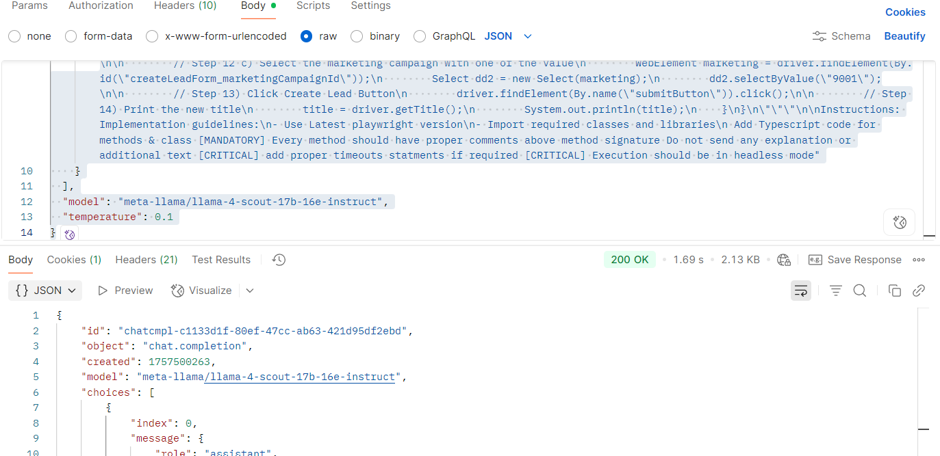

{
"id": "chatcmpl-c1133d1f-80ef-47cc-ab63-421d95df2ebd",
"object": "chat.completion",
"created": 1757500263,
"model": "meta-llama/llama-4-scout-17b-16e-instruct",
"choices": [
{
"index": 0,
"message": {
"role": "assistant",
"content": "```typescript\nimport { chromium, test, expect } from '@playwright/test';\n\ntest.describe('Create Lead', () => {\n test.beforeAll(async () => {});\n\n test('create lead', async ({}) => {\n // Launch browser in headless mode\n const browser = await chromium.launch({\n headless: true,\n });\n\n // Create a new browser context\n const context = await browser.newContext();\n\n // Create a new page\n const page = await context.newPage();\n\n try {\n // Step2) Load the URL (http://leaftaps.com/opentaps/control/main) -> get\n await page.goto('http://leaftaps.com/opentaps');\n\n // Step3) Maximize the chrome browser\n await page.evaluate(() => {\n window.dispatchEvent(new Event('resize', { detail: { width: 1920, height: 1080 } }));\n });\n\n // Step4) Find the username and type the value (DemoSalesManager)\n await page.fill('#username', 'DemoSalesManager', { timeout: 10000 });\n\n // Step5) Find the password and type the value (crmsfa)\n await page.fill('#password', 'crmsfa', { timeout: 10000 });\n\n // Step6) Find the login button and click\n await page.click('.decorativeSubmit', { timeout: 10000 });\n\n // Step7) Verify the title \n const title = await page.title();\n console.log(title);\n\n // Step8) Click CRM/SFA link\n await page.click('text=\"CRM/SFA\"', { timeout: 10000 });\n\n // Step9) Click Create Lead Link\n await page.click('text=\"Create Lead\"', { timeout: 10000 });\n\n // Step10) Find the company name and type the company name\n await page.fill('#createLeadForm_companyName', 'TestLeaf', { timeout: 10000 });\n\n // Step11) Find the first name and type your name\n await page.fill('#createLeadForm_firstName', 'Babu', { timeout: 10000 });\n\n // Step12) Find the last name and type your name\n await page.fill('#createLeadForm_lastName', 'Manickam', { timeout: 10000 });\n\n // Step12 b) Select the Source dropdown with one of the visible text\n await page.select('#createLeadForm_dataSourceId', 'Employee');\n\n // Step12 c) Select the marketing campaign with one of the value\n await page.select('#createLeadForm_marketingCampaignId', '9001');\n\n // Step13) Click Create Lead Button\n await page.click('input[name=\"submitButton\"]', { timeout: 10000 });\n\n // Step14) Print the new title\n const newTitle = await page.title();\n console.log(newTitle);\n } finally {\n // Close browser\n await browser.close();\n }\n });\n});\n```"
},
"logprobs": null,
"finish_reason": "stop"
}
],
"usage": {
"queue_time": 0.087323594,
"prompt_tokens": 680,
"prompt_time": 0.017786121,
"completion_tokens": 619,
"completion_time": 1.425834113,
"total_tokens": 1299,
"total_time": 1.443620234
},
"usage_breakdown": null,
"system_fingerprint": "fp_5d3e4e58e1",
"x_groq": {
"id": "req_01k4sjvhzzeg7rh3q7bc9jtg8m"
},
"service_tier": "on_demand"
}

Formatted code :
import { chromium, test, expect } from '@playwright/test';

test.describe('Create Lead', () => {
test.beforeAll(async () => {
// Setup code can be added here if needed
});

test('create lead', async () => {
const browser = await chromium.launch({ headless: true });
const context = await browser.newContext();
const page = await context.newPage();

try {
// Step 1: Load the URL
await page.goto('http://leaftaps.com/opentaps');

// Step 2: Maximize the browser window (simulated via JS)
await page.evaluate(() => {
window.dispatchEvent(new Event('resize', {
detail: { width: 1920, height: 1080 }
}));
});

// Step 3: Enter username
await page.fill('#username', 'DemoSalesManager', { timeout: 10000 });

// Step 4: Enter password
await page.fill('#password', 'crmsfa', { timeout: 10000 });

// Step 5: Click login button
await page.click('.decorativeSubmit', { timeout: 10000 });

// Step 6: Verify and print page title
const title = await page.title();
console.log('Title after login:', title);

// Step 7: Click "CRM/SFA" link
await page.click('text=CRM/SFA', { timeout: 10000 });

// Step 8: Click "Create Lead" link
await page.click('text=Create Lead', { timeout: 10000 });

// Step 9: Fill out the Create Lead form
await page.fill('#createLeadForm_companyName', 'TestLeaf', { timeout: 10000 });
await page.fill('#createLeadForm_firstName', 'Babu', { timeout: 10000 });
await page.fill('#createLeadForm_lastName', 'Manickam', { timeout: 10000 });

// Step 10: Select options from dropdowns
await page.selectOption('#createLeadForm_dataSourceId', { label: 'Employee' });
await page.selectOption('#createLeadForm_marketingCampaignId', '9001');

// Step 11: Click "Create Lead" button
await page.click('input[name="submitButton"]', { timeout: 10000 });

// Step 12: Print new page title
const newTitle = await page.title();
console.log('Title after lead creation:', newTitle);
} finally {
// Cleanup: Close the browser
await browser.close();
}
});
});

Logs
Running 1 test using 1 worker
Title after login: Leaftaps - TestLeaf Automation Platform
Title after lead creation:
✓ 1 example.spec.ts:8:7 › Create Lead › create lead (15.1s)
1 passed (16.2s)
Files
trace.zip - Open in Trace Viewer
Duration of 17293 ms with Playwright version 1.53.1.

Execution Results from playwright:

